**Trieste, 9-11th July 2019**

**The Holocaust as a Starting Point 2**

***The Holocaust as a starting point***

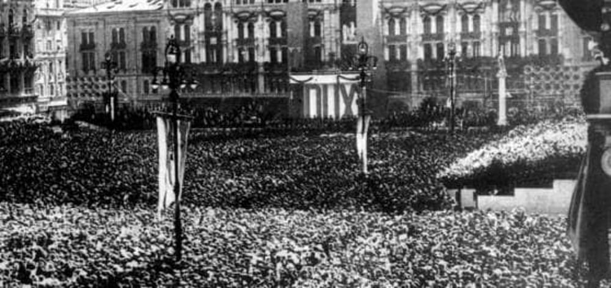





Couverture : Mémorial de la Shoah, Paris / Crédit : Mémorial de la Shoah

Proclamation of the racial laws

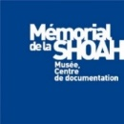

Venue University of Trieste, **University of Trieste- Androna Campo Marzio 10**

Participants 45 Croatian, Slovenian and Italian teachers and 3 representatives from the local agencies

Languages English

Coordinators: **Loranda Miletic**, Croatian Education and Teacher training Agency

**Vojko Kunaver**, Slovenian educational Agency

**Giuseppe Pierro**, Italian Ministry of Education

**Tullia Catalan,** university of Trieste

**Bruno Boyer**, **Laura Fontana** Mémorial de la Shoah

Moderators **Bruno Boyer**, Mémorial de la Shoah

**Tulia Catalan**, university of Trieste

|  |  |  |
| --- | --- | --- |
| **Tuesday, July 9th** | | |
| 9.30am |  | Opening |
| 10.00 am |  | ***Ice-breaking activity*** |
| 10.15 am |  | **Reports from the former trainees** |
| 10.45am |  | Coffee Break |
| 11.00 am |  | ***Pedagogical Workshops***  1-Anti-Semitism and social networks  Fabrice Teicher, Mémorial de la Shoah  2-Border and identity 1946 -1947  Kaja Sirok, Slovenian historical Museum |
| 12.45 pm |  | Lunch |
| 2.00 am |  | ***History of Anti-Semitism***  Joel Kotek, free university of Brussels |
| 3.30 pm |  | Coffe break |
| 3.50pm |  | **Changing borders and identity : 1918-1923**  Borut Klabjan  ***(TBC)*** |

|  |  |  |
| --- | --- | --- |
| **Wednesday, 10th July** | | |
| 9.00 am |  | **Pedagogical workshops**  1-Conspiracy theory: how to challenge?  Fabrice Teicher, Mémorial de la Shoah 2- History images, image history  Ophir Levy, Mémorial de la Shoah |
| 10.30 am |  | Coffe break |
| 10.45 |  | ***The Collaboration in Europe during the Nazi rule***  Tal Bruttmann, EHESS |
| 1.00pm |  | Lunch |
| 2.30 pm |  | ***The German occupation of Italy and the Adriatic Coastland***  René Moehrle, University of Trier |
| 4.00 pm |  | Coffe break |
| 4.15 pm |  | ***The Persecutions against the Jews (NDH, Italian occupied zones and OZAK)***  Tullia Catalan, Trieste University |

|  |  |  |
| --- | --- | --- |
| **Thursday 11th July University of Trieste** | | |
| 9.00 am |  | ***Risiera di San Sabba***  ***Visit of the permanent exhibit*** |
| 11.30am |  | ***Transitional violence in Gorizia and Trieste*** ***(1946-1954)***  Frederico Tenca Montini, University of Teramo |
| 1.00pm |  | Lunch |
| 2.00 pm |  | ***The Situation in the region of Trieste at the Aftermath of WWII***  Pr Pupo (TBC) |
| 3.30 pm |  | Coffee Break |
| 3.45 pm |  | ***Pedagogical Workshops***   1. IHA Guidelines; teaching the Holocaust   Loranda Miletic   1. To be specified |
| 5.45 |  | ***Conclusion*** |

